Flow Control
Flow Control deals with the issue where the sender sends data at the higher rate than the receiver can receive. Flow control can be done by using the buffer on the receiver side. But, the main problem that occurs, in this case, is that the slower receiver cannot handle with the faster sender which causes overflow and loss of data.
Approaches to Flow Control:
      - Feedback-based Flow Control: Receiver sends feedback to the sender telling how it is doing.
      - Rate-based Flow Control: In this approach, pre-communication occurs between sender and receiver and the data transfer occurs at the rate which the receiver can receive without overflow.
- In data communications, flow control is the process of managing the rate of data transmission between two nodes to prevent a fast sender from overwhelming a slow receiver.
- It provides a mechanism for the receiver to control the transmission speed, so that the receiving node is not overwhelmed with data from transmitting node.
- Flow control is important because it is possible for a sending computer to transmit information at a faster rate than the destination computer can receive and process it. This can happen if the receiving computers have a heavy traffic load in comparison to the sending computer, or if the receiving computer has less processing power than the sending computer.
Types of mechanisms can be deployed to control the flow:
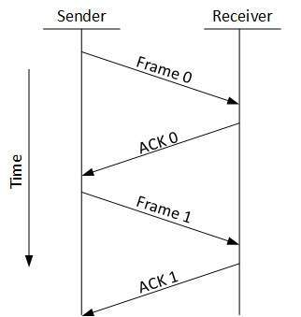
Stop and Wait
      - Stop and Wait
- This flow control mechanism forces the sender after transmitting a data frame to stop and wait until the acknowledgement of the data-frame sent is received.
-, the receiver indicates its readiness to receive data for each frame, the message is broken into multiple frames. The sender waits for an ACK (acknowledgement) after every frame for specified time (called time out).
- It is sent to ensure that the receiver has received the frame correctly. It will then send the next frame only after the ACK has been received.
Operations
- Sender: Transmits a single frame at a time.
- Receiver: Transmits acknowledgement (ACK) as it receives a frame.
- Sender receive ACK within time out.
- Go to step 1.
- If a frame or ACK is lost during transmission, then it has to be transmitted again by sender. This re-transmission process is known as ARQ (automatic repeat request).
- The problem with Stop-and wait is that only one frame can be transmitted at a time, and that often leads to inefficient transmission, because until the sender receives the ACK it cannot transmit any new packet. During this time both the sender and the channel are unutilized.
      - Sliding Window
- Major Drawback of Stop-and-Wait Flow Control: - Only one frame can be in transmission at a time - This leads to inefficiency if propagation delay is much longer than the transmission delay
- Sliding Window Flow Control - Allows transmission of multiple frames - Assigns each frame a k-bit sequence number - Range of sequence number is [0..2k -1], i.e., frames are counted modulo 2k
- Window size: No of frames which sent at a time
- In this flow control mechanism, both sender and receiver agree on the number of data-frames after which the acknowledgement should be sent. As we learnt, stop and wait flow control mechanism wastes resources, this protocol tries to make use of underlying resources as much as possible.
- A method of flow control in which a receiver gives a transmitter permission to transmit data until a window is full. When the window is full, the transmitter must stop transmitting until the receiver advertises a larger window.
- Sliding-window flow control is best utilized when the buffer size is limited and pre-established. During a typical communication between a sender and a receiver the receiver allocates buffer space for n frames (n is the buffer size in frames). The sender can send and the receiver can accept n frames without having to wait for an acknowledgement.
- A sequence number is assigned to frames in order to help keep track of those frames which did receive an acknowledgement.
- The receiver acknowledges a frame by sending an acknowledgement that includes the sequence number of the next frame expected. This acknowledgement announces that the receiver is ready to receive n frames, beginning with the number specified.
- Both the sender and receiver maintain what is called a window. The size of the window is less than or equal to the buffer size. Sliding window flow control has a far better performance than stop-and-wait flow control.
For example, in a wireless environment if data rates are low and noise level is very high, waiting for an acknowledgement for every packet that is transferred is not very feasible. Therefore, transferring data as a bulk would yield a better performance in terms of higher throughput.
The window maintained by the sender indicates which frames he can send. The sender sends all the frames in the window and waits for an acknowledgement (as opposed to acknowledging after every frame). The sender then shifts the window to the corresponding sequence number, thus indicating that frames within the window starting from the current sequence number can be sent.
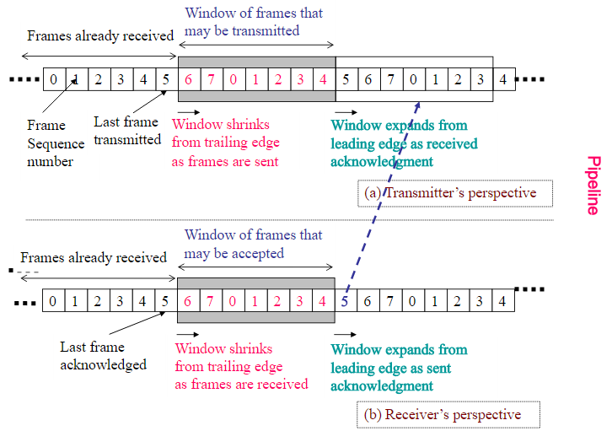
How Flow control is achieved?
• Receiver can control the size of the sending window.
• By limiting the size of the sending window data flow from sender to receiver can be limited .
The example assumes a 3-bit sequence number field and a maximum window size of 2^{n}-1= 7 frames. Initially, Source and Destination have windows indicating that Source may transmit 7 frames, beginning with frame 0 (FO). After transmitting 3 frames (FO, F1, F2) without acknowledgment, Source has contracted its window to 4 frames. The window indicates that Source may transmit 4 frames, beginning with frame number 3. Destination then transmits an RR (receive-ready) 3(RR3), which means: "I have received all frames up to frame number 2(F2) and am ready to receive frame number 3(F3); in fact, I am prepared to receive 7 frames, beginning with frame number 3(F3)." With this acknowledgment, Source is back up to permission to transmit 7 frames, still beginning with frame 3(F3). Source proceeds to transmit frames 3, 4, 5 , and 6. Destination returns an RR 7, which allows Source to send up to and including frame F2.
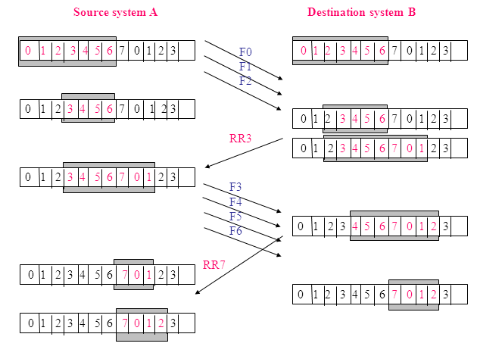
Maximum Window Size = 7

